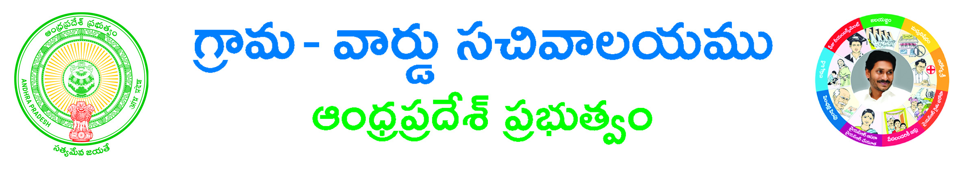
Conversion of White SRI KALAHASTEESWARA SWAMYVARI ROOM BOOKING

Room Type:*:ALLAC NONAC
Check in Date *: ______________________________

Devotee Details
Aadhar Card No: _________________________ Devotee Name*: _______________________________________
Proof Document Name*:___________________________Proof Document No*: ________________________
Gothram: _____________________________Nakshatram: __________________________________________
Gender*: Male Female Age:________________ Mobile Number:* ________________________
Email Id: _______________________________________House No: ____________________________________
Street Name/Location*: ____________________________________________
Country*: INDIA State*: _________________________ District*: ________________________________
Mandal*: ________________________ Village*: ___________________________ Pin Code: _________________
Informant Details
Informant Name*: _________________________ Informant Relation*: _____________________________

Documents List:
(NOTE: 1.Total size of Upload Document should not exceed 3 MB.2. All Upload Documents should be in PDF Format Only)
1. Application Form*
2. Identity Proof *

Applicant’s Signature

