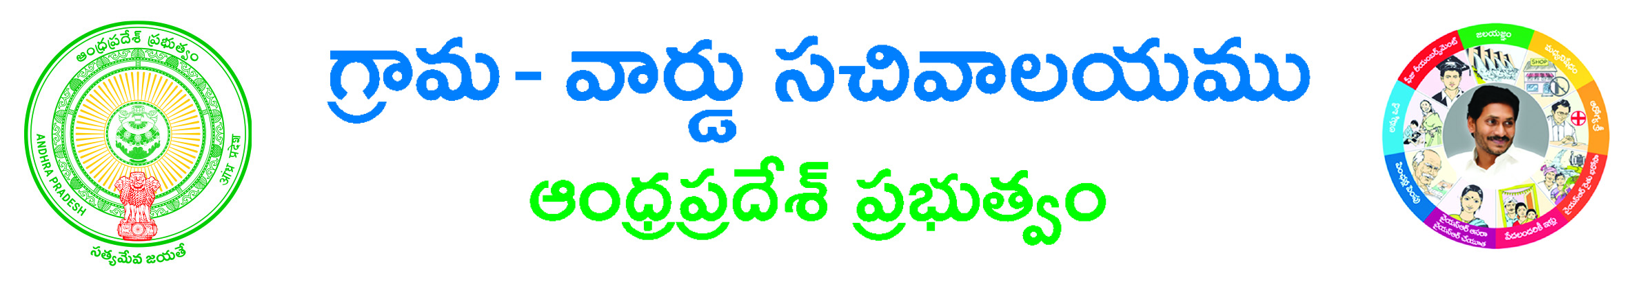
SPDCL Name Change Application Form

Paste here your recent passport size photograph

Name Changes Request Details:-
Service Number*: _____________________________________________
Consumer Details:-
S.No | Consumer Details | Actual Details | Changed Details
1 | Surname
2 | Name
3 | Father Name
4 | Caste
5 | Mobile Number

Service Type: ____________________________ Reason for Name Change: __________________________________________
Location of Premises:-
House No*: ______________Street*: _________________________________________________________________________
Circle*: GUNTUR KADAPA NELLORE ONGOLE TIRUPATHI VIJAYAWADA
Division *:___________________________ Sub Division*: ______________________________ Pin Code: _________________ Sub Category: ____________________________________________________ Location Type*: Urban Rural
Location Name*: ______________________________________________________ Load Connected: _____________________
Dispatch No: _________________________________
Informant Details:-
Aadhar Number: ______________________________Informant Name*: ____________________________________________ Relation*: _________________ Door No: _________________ Locality/Land Mark:____________________________
State*:_____________________District*: _________________________ Mandal*: ____________________
Village/Ward*: ____________________Pin Code: _________________Mobile Number*: ___________________
Email ID: ___________________________________
Delivery Type*: Manual
Security Deposit (Available) *: _______________________
Proof Document*: Gift Deed Sale Deed Ownership Certificate Indemnity Bond
ID Proof*: Aadhar Card Copy Driving License Copy Electoral Copy Pan Card copy Ration card copy
Document List: - (NOTE: All Upload Documents are in PDF Format Only)
Application Form*
ID Proof*
Caste Certificate (Mandatory if SC/ST) *
Owner Ship Certificate/Sale Deed/Gift Deed (Selected Proof Document) *
Municipality/Gram panchayat Permission Letter*
Indemnity Bond*
Transfer Transferee Document*
Latest Bill and Receipt*
Applicant’s Signature

