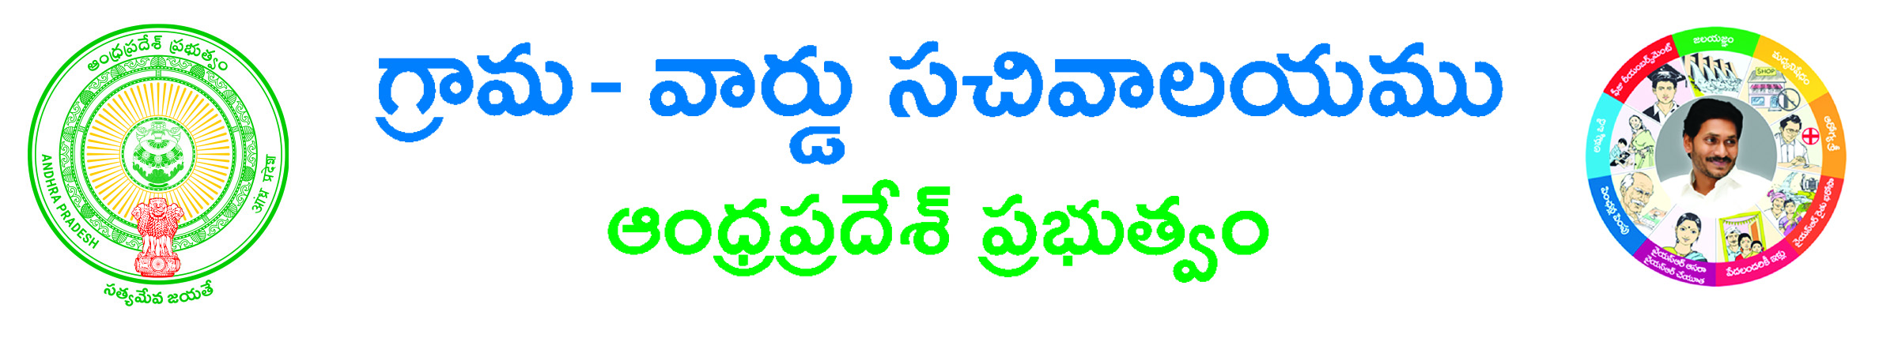

Fresh or Renewal License Application

Applicant Details (address for communication):-
Aadhaar Card No: ____________________Name of Applicant (in BLOCK letters)*: ___________________
Surname*: ___________________Father/Husband Name*: _______________ Gender *: ___________
Occupation *: ___________
State *: ___________________District*: ________________ Mandal*: __________________
Village / Ward *: ______________________ Door No: ________________________________
Locality/Land Mark: ______________ Pin Code: ___________ Mobile No*: ______________
Email ID: ______________
Informant Details:-
Informant Name*: _____________________________ Informant Relation*: ___________________
Delivery Type*: Manual Local Non-Local Mobile NO*:_____________________

Service Specific Details
Service required For *(Bars/Dhabas,Fresh 3 star hotel, Fresh 5 star hotel, Renewal 3 star hotel, Renewal 5 star hotel, Ordinary Hotels / Restaurants, Theme / Entertainment Park / Resorts): _____________________________________
District/Commissionerate *: _____________ Police Station Jurisdiction Known *(Yes/NO):_______________
If Yes provide Police Station*: _______________, If No provide Nearest Landmark/ Area Description*:_______________
Remarks *:_______________

Document List:-
- ID Proof*
- Address Proof*
- If any other Documents.

Applicant’s Signature

