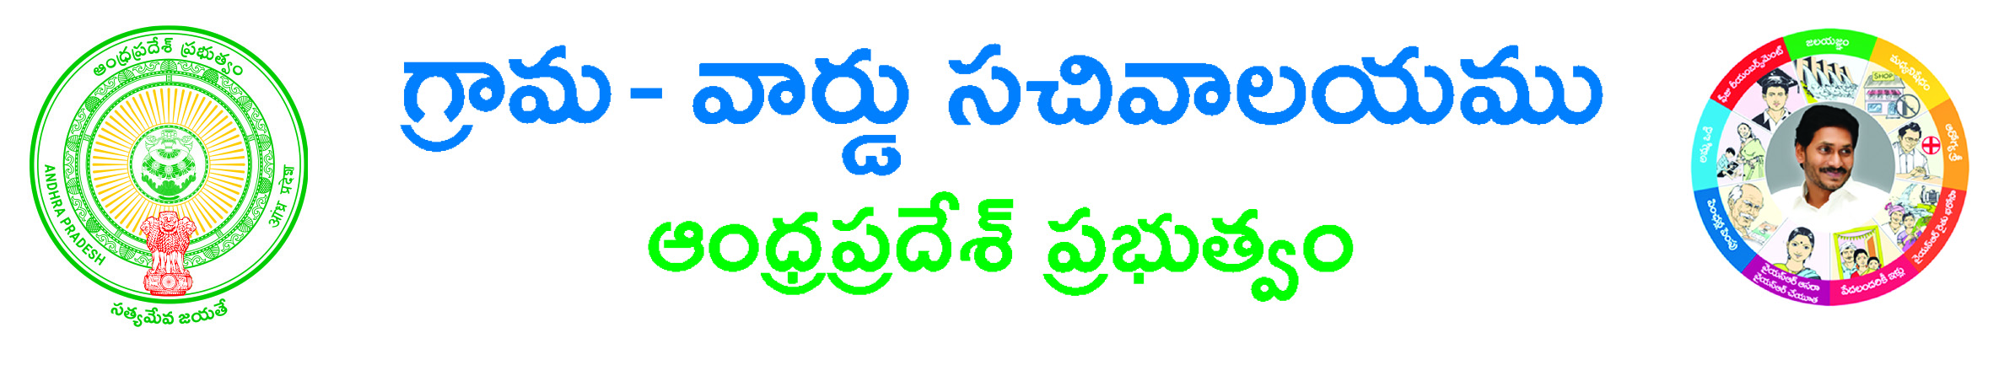

APPLICATION FOR BIRTH CERTIFICATE
(Write in Capital Letters)

CIRCLE/LOCALITY:

1. Date of Birth :
2. Sex :
3. Child Name :
a) If Registered Mention the Child Name.
b) If Child Name not included a separate form to be filled by the Father and
Mother of the child
4. Name of the Father :
5. Name of the Mother :
6. Place of Birth :
(Tick the appropriate entry a, b, c below and give the name of the Hospital/Institute or the
Address of the House where the Birth took place. If other place gives location)
a) Hospital/Institution Name :
b) House Address :
c) Other place :
7. No. Of Copies Required :
8. a) Do you want the Birth Certificate by Courier- Yes / No
b) If Yes give Name and Address with Pin Code

Name & address, (Signature of the Applicant)
Telephone No:

Note: - Birth certificate will be issued subject to entry found Registered in BIRTH RECORDS-C&DMA/PANCHYATS.

