User Manual on Facial Authentication for Marking the Attendance
Method 1:
The employee can directly go to the Play Store and download the latest version of GSWS Attendance App V2.0.6
Play Store Link:
https://play.google.com/store/apps/details?id=com.gswsattendance

Method 2:
Step 1: Open Grama Ward Sachivalayam Attendance App and login with the assigned Credentials.
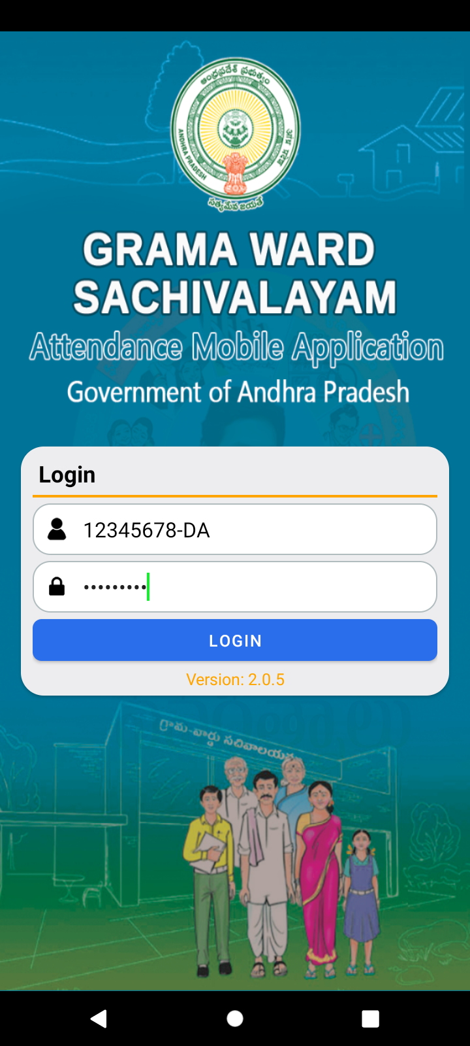

Step 2: Select the Employee type and Employee Name as shown below.
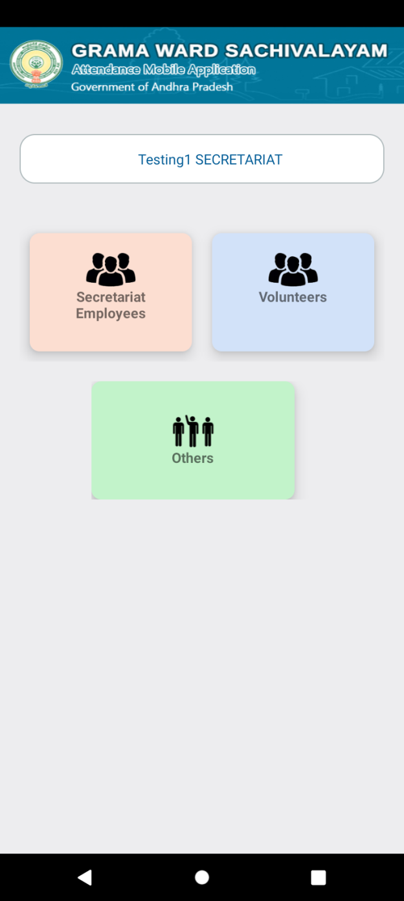 | 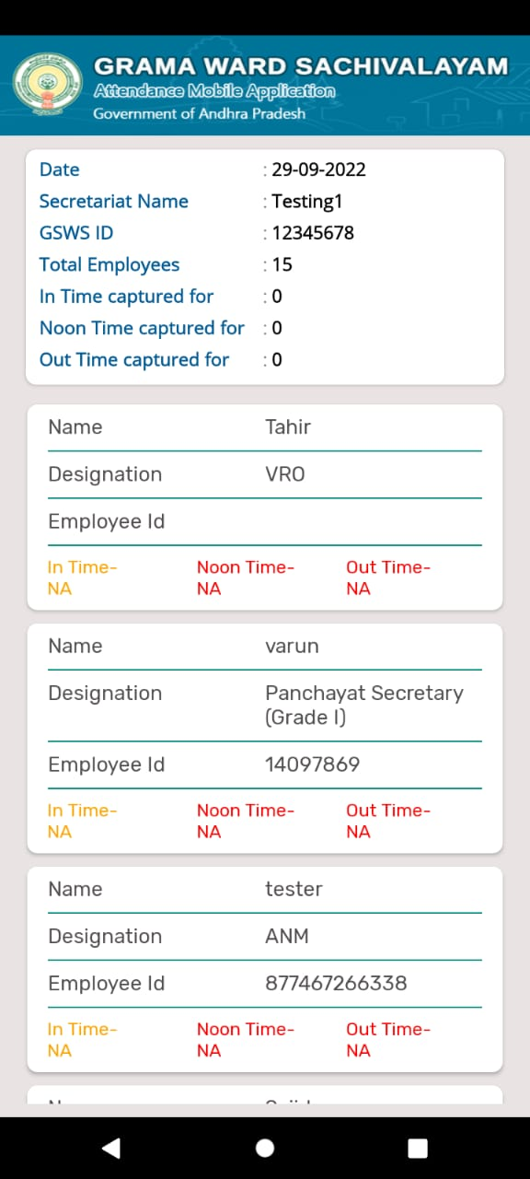

Step 3: Select the Type of Attendance as Face and give the consent for storing Aadhaar detail to the Department. A Face RD app installation Recommendation will be displayed.
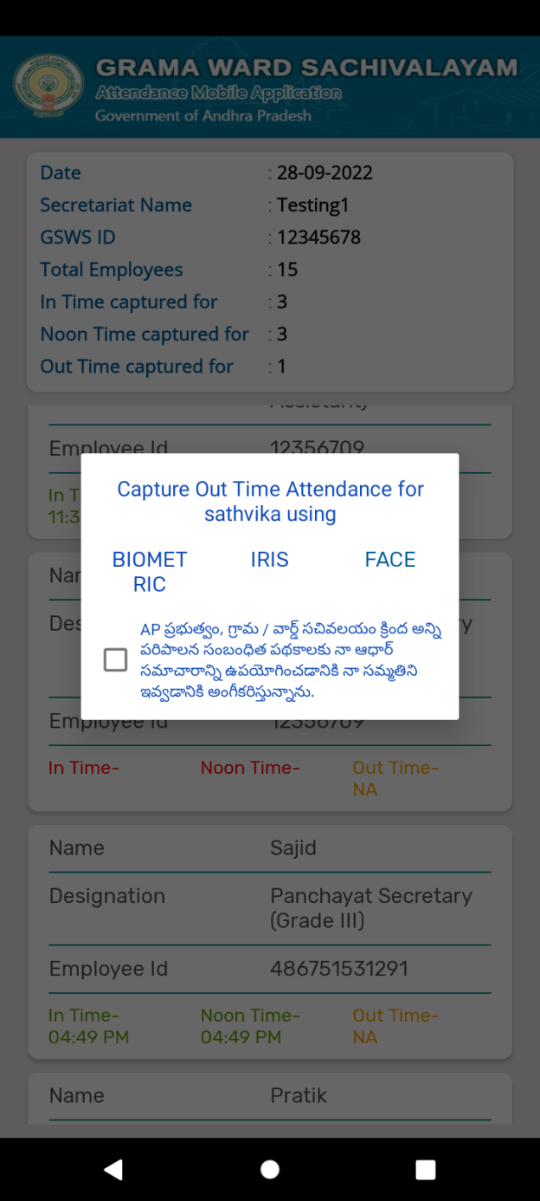 | 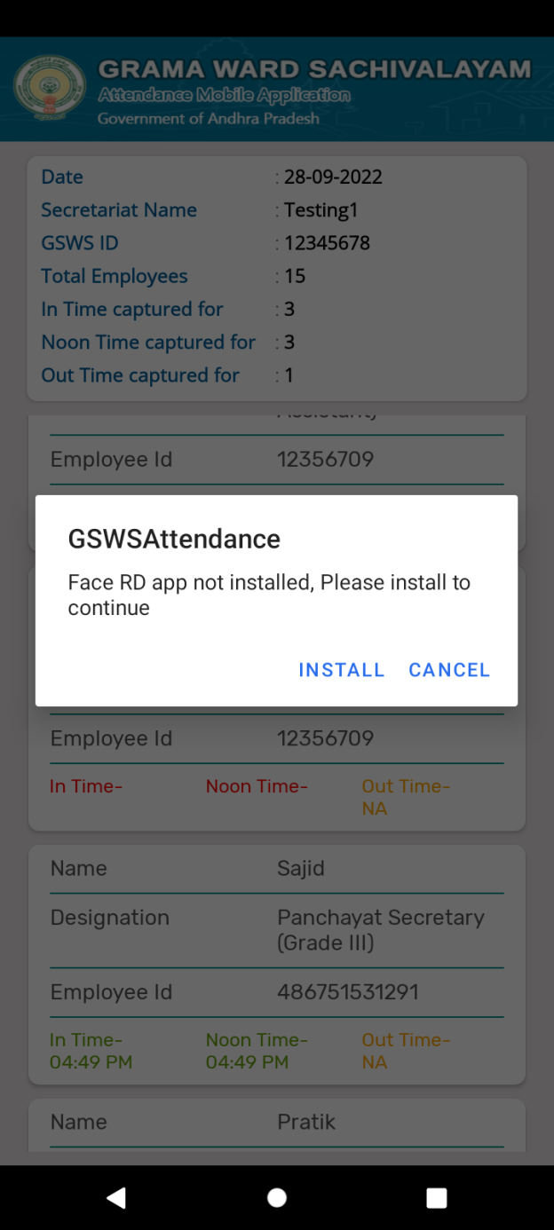

Step 4: Once you click “Install”, it will get redirected to Play Store where you can install the app. Now, open the attendance app and click of “Face” attendance capture.
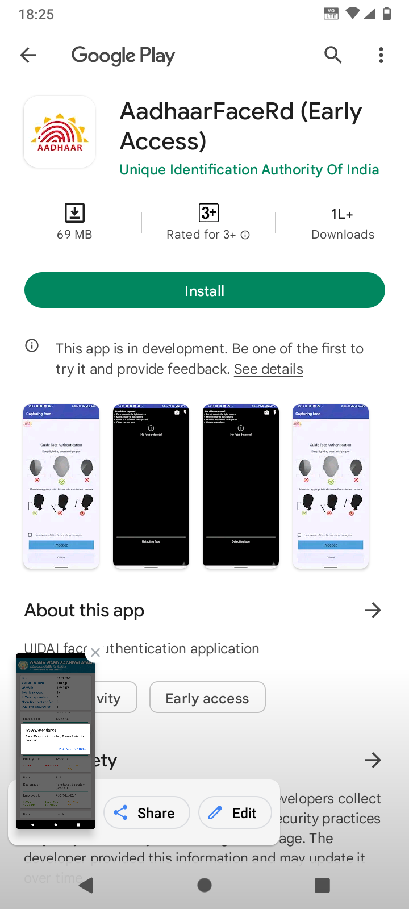

Step 5: As shown in the below pictures, please keep the mobile at an appropriate position to capture the picture. Please hold the mobile phone still and please blink to capture the picture.
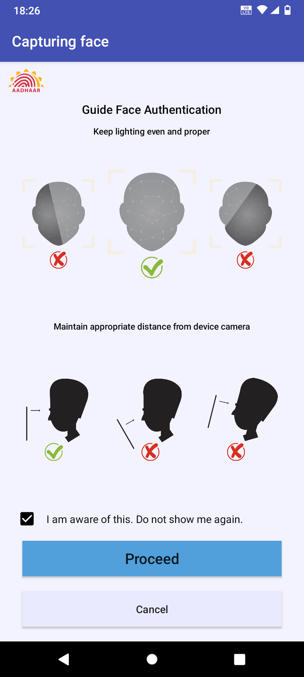 | 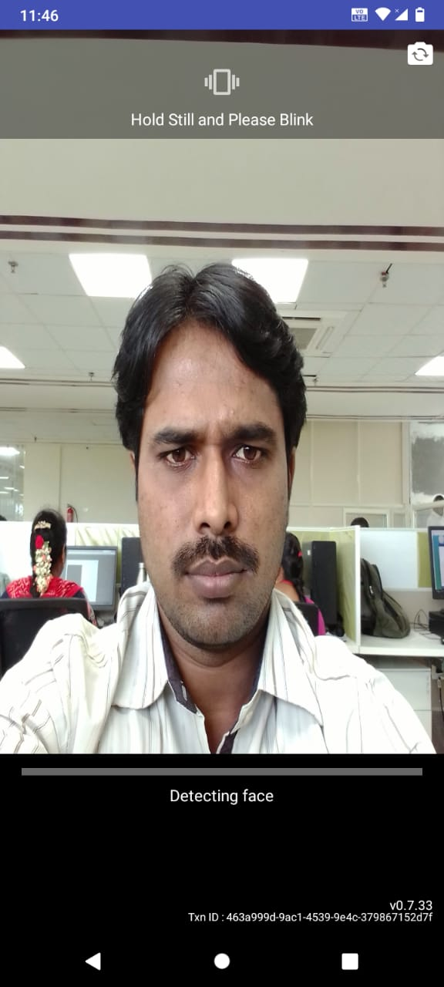

Step 6: Once the Picture is captured, “Image Captured Successfully” message will be displayed and attendance is captured successfully.
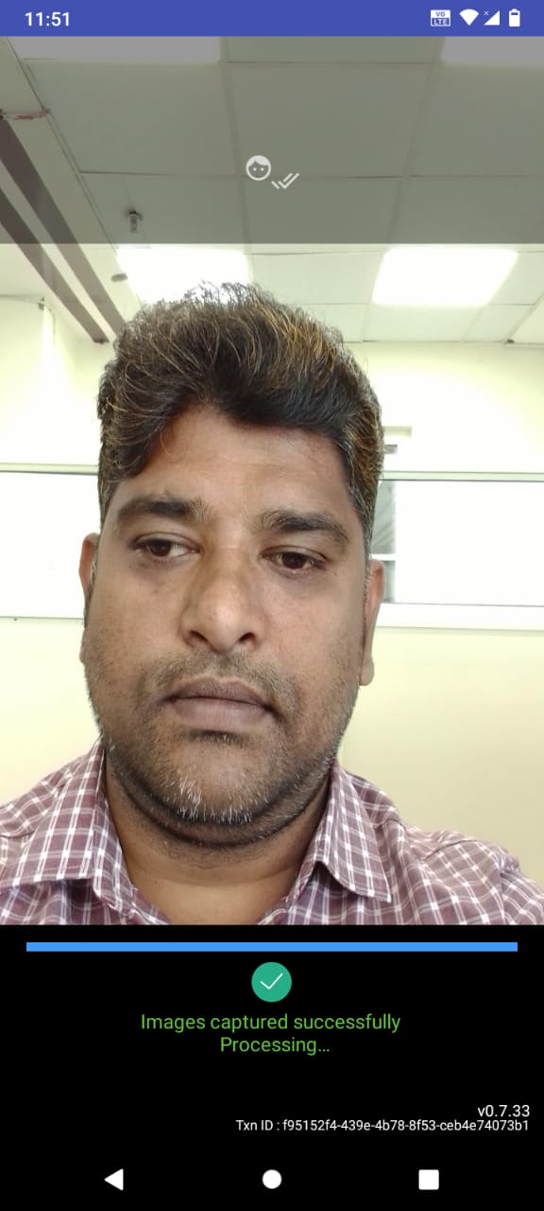 | 